Active Terminate And Stay Resident

**(SUBJECT:- ADVANCE MICROPROCESSOR ARCHITECTURE)**

**(SEMESTER V)**

**SUBMITTED TO THE DEPARTMENT OF**

**INFORMATION TECHNOLOGY**

Dharmsinh Desai University



**Prepared by:- Submitted To:-**

**- Shah Antriksh (IT-112) -** **Prof. Rajendra Chhajed**

# DHARMSINH DESAI UNIVERSITY

# FACULTY OF TECHNOLOGY



DEPARTMENT OF INFORMATION TECHNOLOGY

This is to certify that Mr. Shah Antriksh (IT-112) student of B.Tech Information Technology Semester **V** of DHARMSINH DESAI UNIVERSITY, NADIAD has successfully completed his term project in subject ADVANCE MICROPROCESSOR ARCHITECTURE during the academic year 2013. During the whole term he was found sincere, hardworking and punctual. He made a project on Active Terminate And Stay Resident**.**

|  |  |
| --- | --- |
| Staff in Charge | Head Of Department |
| Date : | Date : |

ACKNOWLEDGEMENT

This project has taught me how to apply theoretical knowledge of Assembly language and Microprocessor into a practical project. It was, though a firsthand experience in project building, it inculcated in me a great awareness in all the stages of project building right from tracing the original interrupt vectors to the final implementation using modified interrupts and graphics.

I wish to express my sincere gratitude to Prof. R.S.Chajjad of Dharmsinh Desai University for providing me an opportunity to do my project work on “Active Terminate And Stay Resident”. His continued support and guidance has been the only reason for this successful project completion. This project bears an imprint of many peoples. I wish to express my gratitude to the other professors of the Information Technology department who rendered their help and kind co-operation to the completion of my project work. Last but not the least I wish to avail myself of this opportunity, to express a sense of gratitude and love to my friends and my beloved parents for their manual support, strength, and help. 

**INDEX**

|  |  |
| --- | --- |
| PAGE NO | TITLE |
| 5 | Chapter-1  1.1 System Overview  1.1.1 Definition  1.1.2 Functionality |
| 2 | Chapter-2  2.1 Assembly Code |
| 5 | Chapter-3  3.1 Applications |
| 14 | Bibliography |

**Chapter : 1**

**1.1 System Overview:-**

**1.1.1 Definition**

* This project is to build an active TSR which detects an idle keyboard for 10 seconds and brings on a screen saver.

**1.1.2 Functionality**

The TSR is loaded by running the exe file manually or loading the exe file at the startup of MS-DOS. The TSR hooks up interrupt INT 08 and INT 09. INT 09 checks for a key press. INT 08 checks for an ideal keyboard for roughly 10 seconds. It then loads the video memory with a predefined screen saver. As soon as a keystroke is recorded, the video memory is reloaded with the original screen.

**Chapter 2**

**2.1 Assembly Code**

CODE SEGMENT

ASSUME CS:CODE,DS:CODE,ES:CODE

ORG 100H

START : JMP BEGIN

TIMER_IP DW ?

TIMER_CS DW ?

KB_IP DW ?

KB_CS DW ?

FLAG DB 0

CNT DB 180

BUFFER DW 2000 DUP(0)

TIMER:

PUSH AX

PUSH BX

PUSH CX

PUSH DX

PUSH SI

PUSH DI

PUSH DS

PUSH ES

MOV AX,CS

MOV DS,AX

MOV ES,AX

CMP FLAG,00H

JNE TIMER_END

DEC CNT

JNE TIMER_END

CLD

MOV AX,0B800H

MOV DS,AX

MOV SI,0000H

MOV DI,OFFSET BUFFER

MOV CX,2000

REP MOVSW

MOV AX,0B800H

MOV ES,AX

MOV DI,0000H

MOV AL,48

MOV AH,89

MOV CX,2000

REP STOSW

MOV CS:FLAG,01H

TIMER_END:

POP ES

POP DS

POP DI

POP SI

POP DX

POP CX

POP BX

POP AX

JMP DWORD PTR CS:TIMER_CS

KB:

PUSH AX

PUSH BX

PUSH CX

PUSH DX

PUSH SI

PUSH DI

PUSH DS

PUSH ES

MOV AX,CS

MOV DS,AX

MOV ES,AX

MOV CNT,180

CMP FLAG,01

JNE KB_END

CLD

MOV AX,0B800H

MOV ES,AX

MOV SI,OFFSET BUFFER

MOV DI,0000H

MOV CX,2000

REP MOVSW

MOV FLAG,00H

KB_END :

POP ES

POP DS

POP DI

POP SI

POP DX

POP CX

POP BX

POP AX

JMP DWORD PTR CS:KB_CS

BEGIN:

MOV AX,CS

MOV DS,AX

MOV ES,AX

MOV AH,35H

MOV AL,08H

INT 21H

MOV TIMER_IP,BX

MOV TIMER_CS,ES

MOV AH,35H

MOV AL,09H

INT 21H

MOV KB_IP,BX

MOV KB_CS,ES

MOV AH,25H

MOV AL,08H

MOV DX,OFFSET TIMER

INT 21H

MOV AH,25H

MOV AL,09H

MOV DX,OFFSET KB

INT 21H

MOV AH,31H

MOV DX,OFFSET BEGIN

SHR DX,04h

INC DX

INT 21H

CODE ENDS

END START

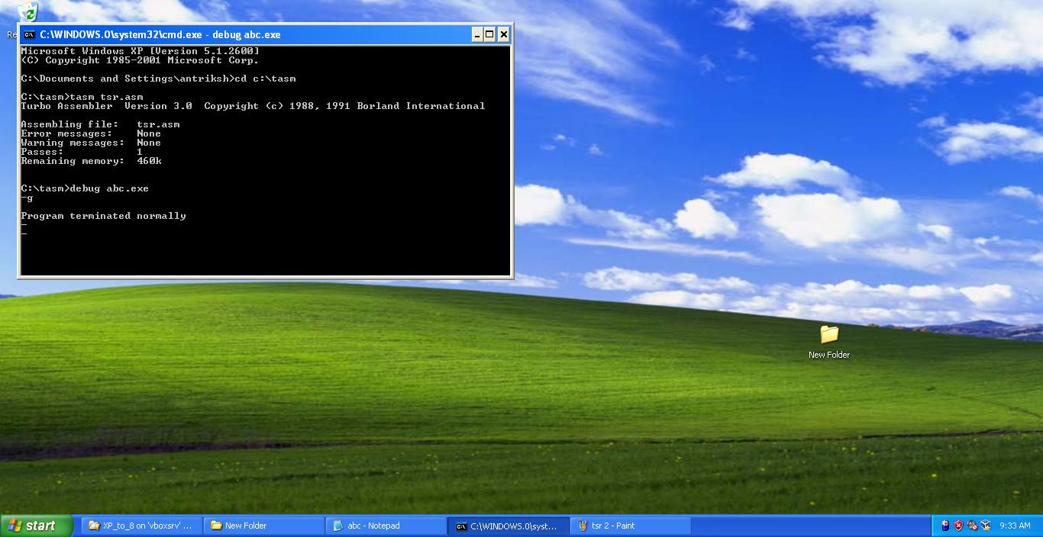

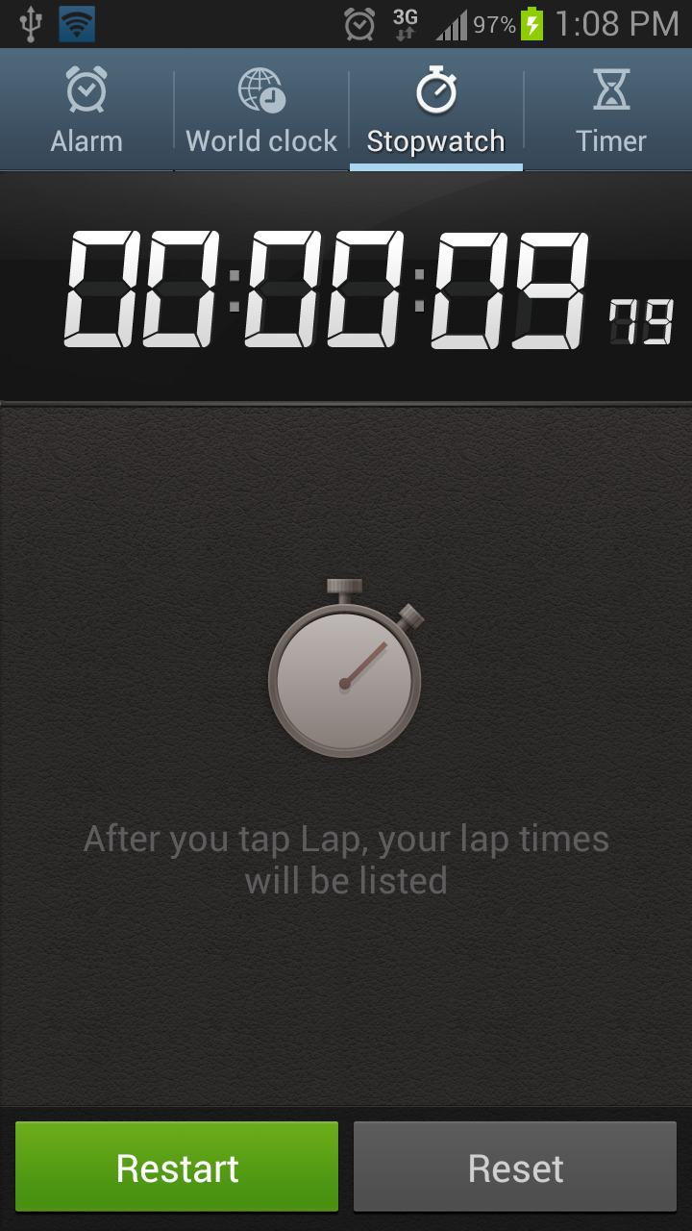

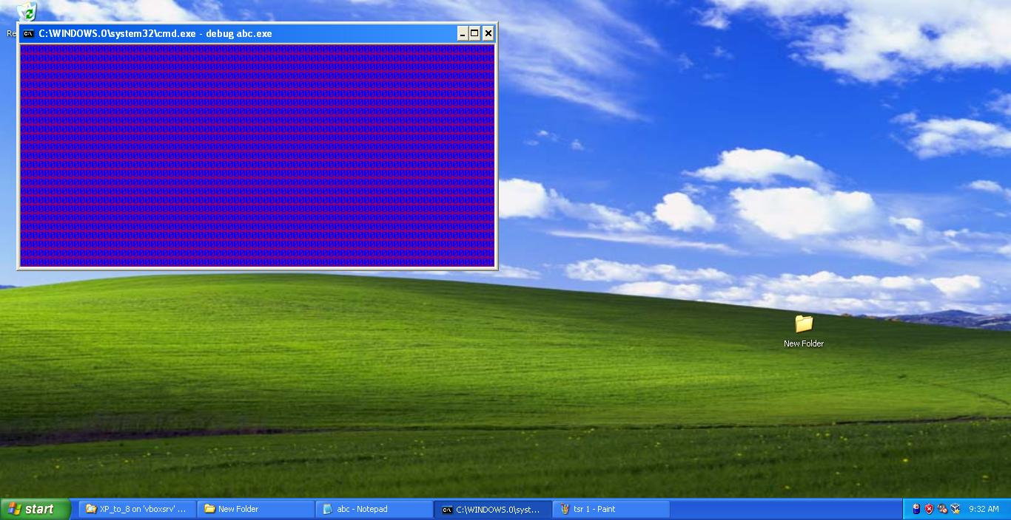

**Flowchart:**

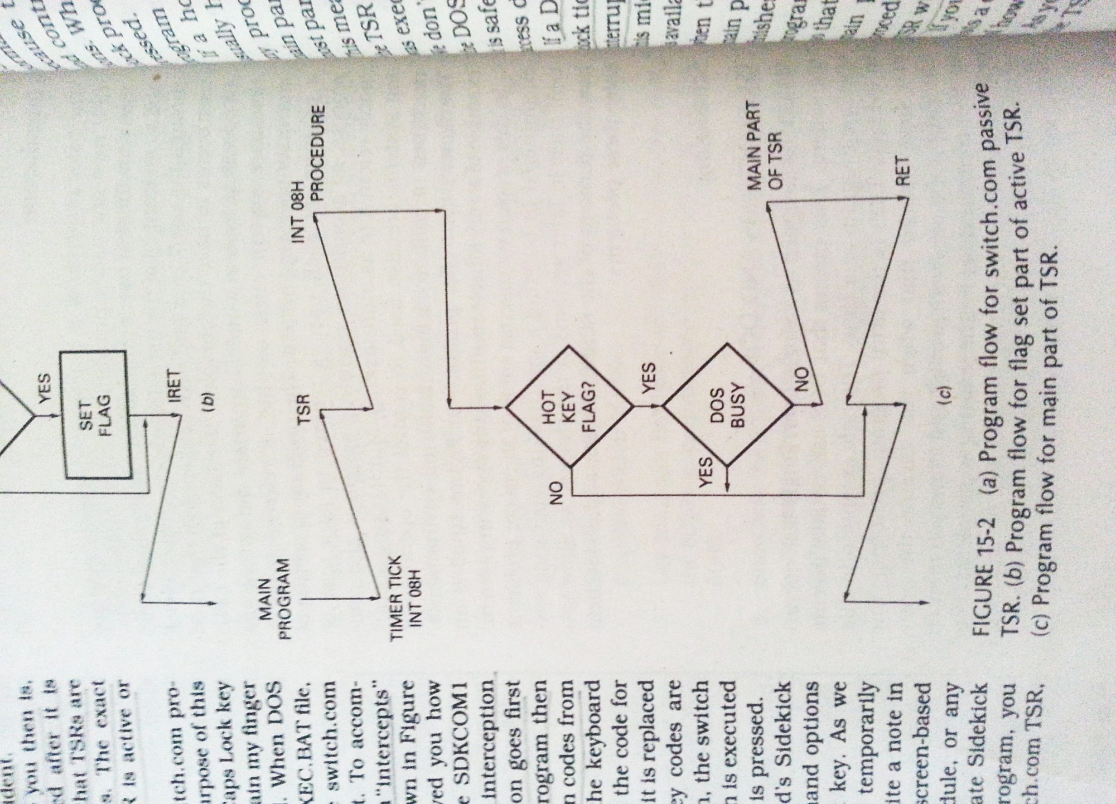

Set sophamore 0

**Chapter 3**

**3.1 Applications:-**

1. Key Logger

This active TSR will record keystrokes and store it in a text file. This is one popular tool used by hackers to access usernames and passwords entered over the World Wide Web.

1. Alarm Clock

This active TSR will decrement the user time and checks if it is zero. As soon as it reaches zero an alarm will start to beep.

1. Pop Up Reminders

Similar to an Alarm Clock, Pop up reminders counter on reaching zero brings up reminders on the screen.

1. Screensaver

Screen Savers are the most efficient way to save energy for an idle work station. Also they can be password protected and hence one can leave a workstation without having to worry about the privacy.

1. Virus

A TSR can be used for malicious activities. The interrupts can be hooked up to delete files, hang system, or worse crash MS-DOS. On that note an antivirus is built which can be used to prevent such malicious activities.

**Bibliography**

*Web Sites:*

www.webpages.charter.net

cs.smith.edu/~thiebaut/ArtOfAssembly

www.wikipedia.org

*Books:*

MICROPROCCESSORS AND INTERFACING PROGRAMMING AND HARDWARE SECOND EDITION BY : DOUGLAS V. HALL

IBM PC ASSEMBLY LANGUAGE AND PROGRAMMING THIRD EDITION BY : PETER ABEL

THE INTEL MICROPROCESSOR ARCHITECTURE, PROGRAMMING, AND INTERFACING FOURTH EDITION BY : BARRY B. BREY